**EXPERIMENT -5**

**EXP NO 5:** CREATE A SIMPLE CLOUD SOFTWARE APPLICATION FOR LIBRARY BOOK RESERVATION SYSTEM FOR SIMATS LIBRARY USING ANY CLOUD SERVICE PROVIDER TO DEMONSTRATE SAAS

**DATE: 29/09/25**

**AIM**: To Create a simple cloud software application for Library book reservation system for SIMATS library using any Cloud Service Provider to demonstrate SaaS

**PROCEDURE:**

**Step1: Go To Zoho.Com.**

**Step 2: Log Into the Zoho.Com.**

**Step 3: Select One Application Step.**

**Step4: Enter Application Name as Library Book Reservation System.**

**Step 5: Created New Application as Library Book Reservation System.**

**Step 6: Select One Form.**

**Step 7: The Software Has Been Created.**

Form 1: Field form

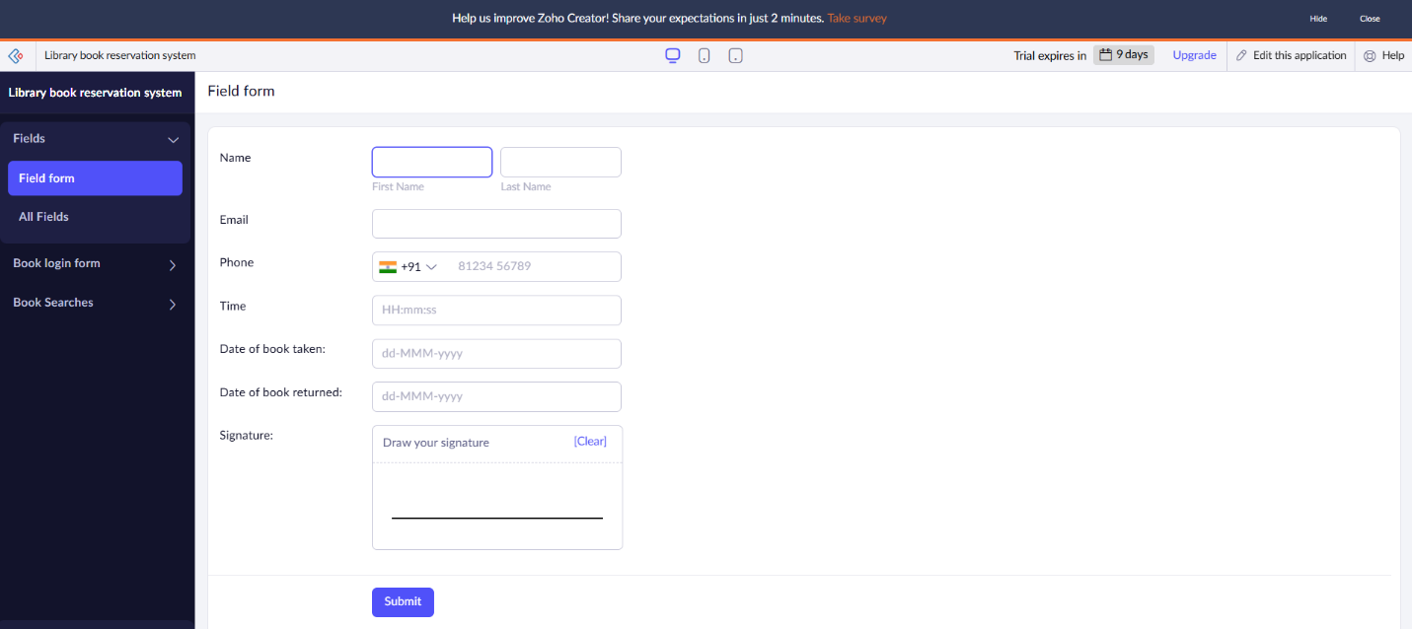

Form 2: Book login form

Form 3: Book search form

Form 1: Field form

Form 2: car search & booking form.

Form 3: Book search form

Result: A cloud-based Library Book Reservation System for SIMATS Library can be implemented as a SaaS application using platforms like Azure or AWS, offering users online access to search, reserve, and manage books through a web interface backed by cloud-hosted APIs and databases.